EXPERIMENT 5
HEX TO BCD

Submitted by,
T Raja Aadhithan
Code:
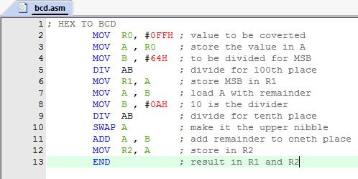

Output:

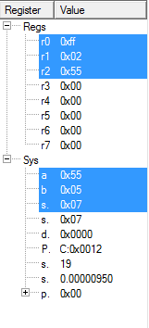
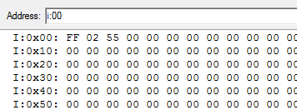

input: R0
output: R1 and R2

